📊 Arduino Data Logger (DS18B20 + Light Sensor + SD Card)
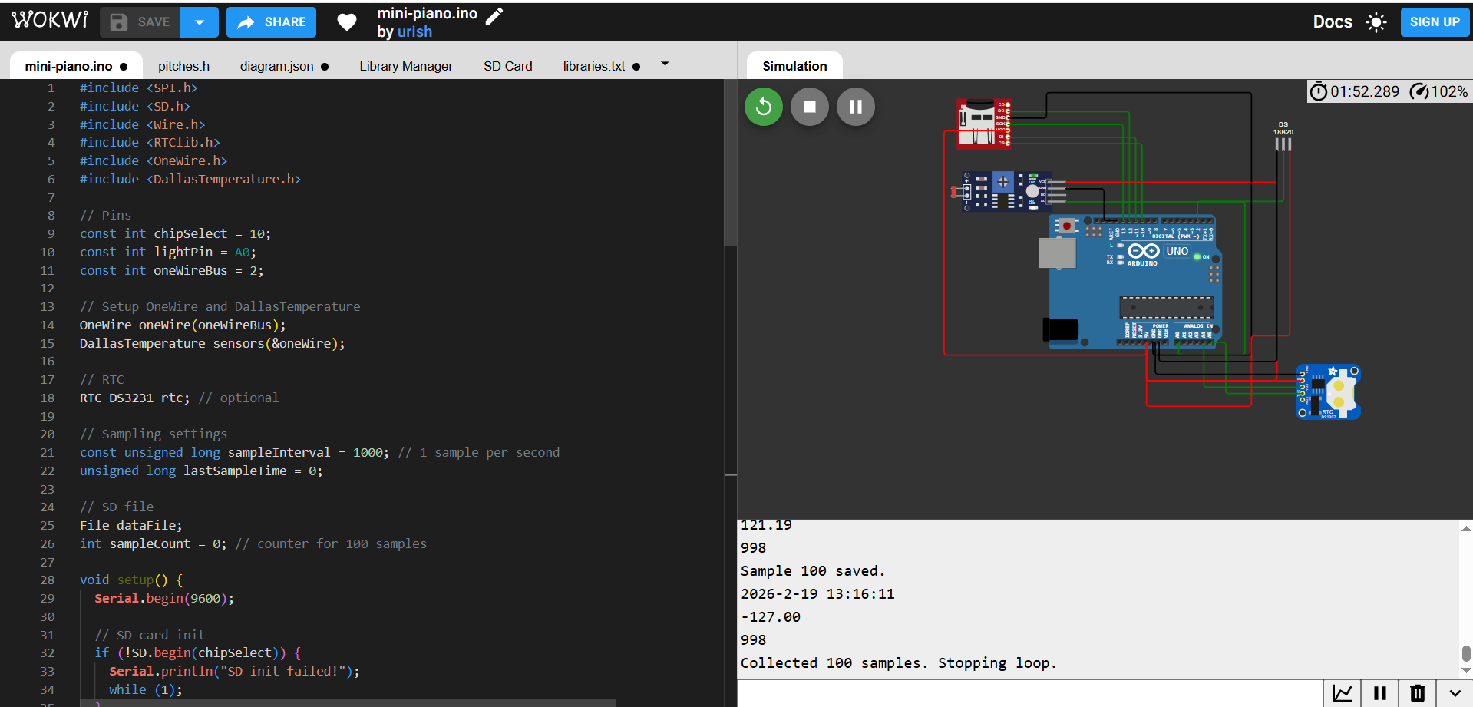

📌 Project Overview
This project implements a sensor data logger using an Arduino Uno. The system collects:
- 🌡 Temperature data from a DS18B20 digital sensor
- 💡 Light intensity data from a photoresistor
- 🕒 Timestamp data from an optional DS3231 RTC module
All readings are saved as timestamped CSV entries to an SD card. The system records at least 100 samples automatically.

1. Hardware (Wokwi / Arduino)
Components:
Component | Pin / Connection
Arduino Uno | —
DS18B20 | D2 (data) + 4.7kΩ pull-up to 5V
Photoresistor | A0 (analog input)
SD card module | CS=D10, MOSI=D11, MISO=D12, SCK=D13
RTC DS3231 (optional) | SDA=A4, SCL=A5

🧰 Hardware Components
- Arduino Uno
- DS18B20 Temperature Sensor
- Photoresistor (LDR)
- SD Card Module (SPI interface)
- DS3231 RTC Module (optional)
- 4.7kΩ resistor (pull-up for DS18B20)

🔌 Pin Connections
Component | Arduino Pin
DS18B20 Data | D2
Light Sensor | A0
SD Card CS | D10
SD MOSI | D11
SD MISO | D12
SD SCK | D13
RTC SDA | A4
RTC SCL | A5

📂 Output File (CSV Format)
File name: data.csv
Format:
Timestamp,Temperature_C,Light
2026-02-19 12:00:01,23.6,512
2026-02-19 12:00:02,23.7,518
...
- Minimum of 100 samples
- Comma-separated format
- Compatible with Excel, MATLAB, Python, etc.

⏱ Sampling Rate
- Sampling interval: 1 sample per second (1000 ms)
- Total time to collect 100 samples: ~100 seconds
- Controlled using:
const unsigned long sampleInterval = 1000;

Why 1 second?
- Temperature and ambient light change slowly.
- Prevents unnecessary SD card writes.
- Balances data resolution and power efficiency.

🔋 Power Considerations

1️⃣ SD Card Power Usage
- Highest power consumer (~50–100 mA during write).
- Optimization strategy:
  - Buffer multiple readings in RAM before writing.
  - Reduce write frequency.

2️⃣ Arduino Power Optimization
- Use sleep mode between samples.
- Example (LowPower library):
- LowPower.powerDown(SLEEP_1S, ADC_OFF, BOD_OFF);

3️⃣ DS18B20 Efficiency
- Low standby current (~1 mA).
- Can operate in parasite power mode.

4️⃣ Sampling Trade-Off
Lower sampling rate → lower power consumption → longer battery life.

✅ Project Features
- Digital temperature sensing (high accuracy ±0.5°C)
- Real-time timestamp logging
- Structured CSV output
- Stops automatically after 100 samples
- Expandable for more sensors

💻 Arduino Code
#include <SPI.h>
#include <SD.h>
#include <Wire.h>
#include <RTClib.h>
#include <OneWire.h>
#include <DallasTemperature.h>

// Pins
const int chipSelect = 10;
const int lightPin = A0;
const int oneWireBus = 2;

// Setup OneWire and DallasTemperature
OneWire oneWire(oneWireBus);
DallasTemperature sensors(&oneWire);

// RTC
RTC_DS3231 rtc; // optional

// Sampling settings
const unsigned long sampleInterval = 1000; // 1 sample per second
unsigned long lastSampleTime = 0;

// SD file
File dataFile;
int sampleCount = 0; // counter for 100 samples

void setup() {
Serial.begin(9600);

// SD card init
if (!SD.begin(chipSelect)) {
Serial.println("SD init failed!");
while (1);
}
Serial.println("SD initialized.");

// DS18B20 init
sensors.begin();

// RTC init
if (!rtc.begin()) {
Serial.println("RTC not found!");
}

// Create CSV file
dataFile = SD.open("data.csv", FILE_WRITE);
if (dataFile) {
dataFile.println("Timestamp,Temperature_C,Light");
dataFile.close();
}
}

void loop() {
unsigned long currentTime = millis();

if (currentTime - lastSampleTime >= sampleInterval && sampleCount < 100) {
lastSampleTime = currentTime;
sampleCount++;

// Read sensors
int lightVal = analogRead(lightPin);
sensors.requestTemperatures();
float temperatureC = sensors.getTempCByIndex(0);

// Timestamp
DateTime now = rtc.now();
String timestamp = String(now.year()) + "-" + String(now.month()) + "-" + String(now.day()) + " "
+ String(now.hour()) + ":" + String(now.minute()) + ":" + String(now.second());

// Write to SD
dataFile = SD.open("data.csv", FILE_WRITE);
if (dataFile) {
dataFile.print(timestamp);
dataFile.print(",");
dataFile.print(temperatureC);
dataFile.print(",");
dataFile.println(lightVal);
dataFile.close();
Serial.print("Sample ");
Serial.print(sampleCount);
Serial.println(" saved.");
Serial.println(timestamp);
Serial.println(temperatureC);
Serial.println(lightVal);
} else {
Serial.println("Error opening file");
}
}

// Optional: stop after 100 samples
if (sampleCount >= 100) {
Serial.println("Collected 100 samples. Stopping loop.");
while (1); // stop
}
}

